Setup & painting techniques for digital painting by Bob MacNeil

SKETCH
STEP 1: Plan
The story I want to create is centered around the terrible subject of cancer. Though a depressing subject, this is the story behind this particular piece, I jotted down some keywords to start with. Sadness, inspiration, curiosity, innocence and vastness are a few of the words I came up with. I figured an innocent young girl with a curiosity towards the vastness of life, is inspired by an overwhelming sadness she senses from a secondary character. I wanted this additional character to represent security as well, so I went with the obvious choice of including this young girls' father. It's this generalized plan that has provided me with a sort of back-story, which in turn will help me create the actual story. I use this word association process to pretty much plan what the entire world I am creating for this book will look like.

STEP 2: Thumbnails
A drawing can begin with an infinite amount of approaches. I like to work out my ideas on a Post-It note. The small size allows you to explore a large amount of ideas quickly and efficiently. When you see that you have a hint of direction in your thought processes you can take these accumulated scribbles, adhere them to a bigger page (or wall for that matter) and review your visual thinking with a fresh eye. This way you allow yourself a chance to step away (so to speak) and decipher all the gibberish you have committed to paper. It gives you the opportunity to weed out potential directions that may have completely missed the mark, and expand on the ones that hit it. This process should be very loose. Explore ideas you may not typically lean towards. Have fun with it! UNFORTUNATELY, I did not keep any of my thumbnails or take a picture of my workspace for this project. So, to give you an idea of what you're missing... take some sticky notes, (about 50 or so) a pencil sharpener, a couple of pencils and a big mess of a desk and you'll feel like you're sitting on my lap. For book creation, the entire book should be nailed out to ensure good story flow and progression and to see if what you intend to produce can be achieved. Sorry, I did not save all my preliminary thumbnail sketches.

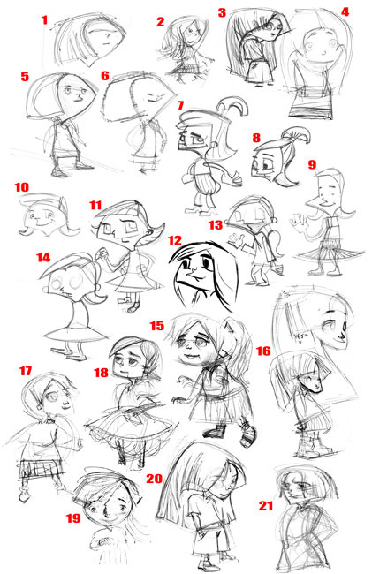

STEP 3: Rough
Working from the idea board you created for yourself, extract elements from let's say, thumbnails 1, 2 and maybe even 3 (you decide) and work up a rough sketch. The size of this rough sketch should be drawn proportionate to the size you intend on making the final image.
This is what I came up with after countless attempts that were scratched because they did not evoke the feeling I was after. This is where having a plan or goal was handy. I could have simply produced an illustration, but when considering the overall intention of this book, the context of each image created has to have relevance. (see fig. 1)
After working my thumbnail to this proportionate size, I still felt the characters were not expressing the emotions I was looking for. On another sheet of paper I drew the characters by themselves. I felt this may be the best way to find what I was after, because I felt it necessary to temporarily eliminate the distraction of the presently busy background. (see fig. 2)

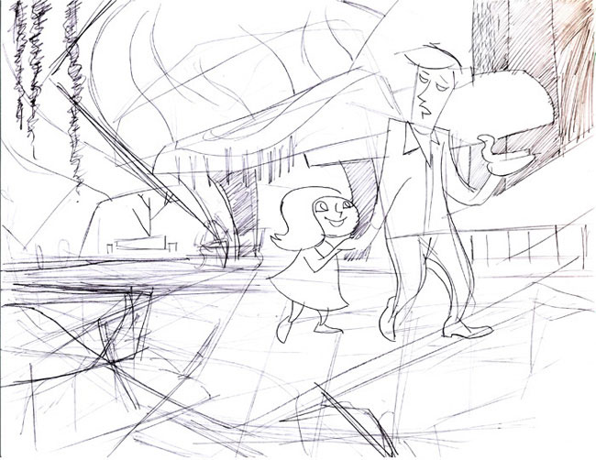
Fig.1

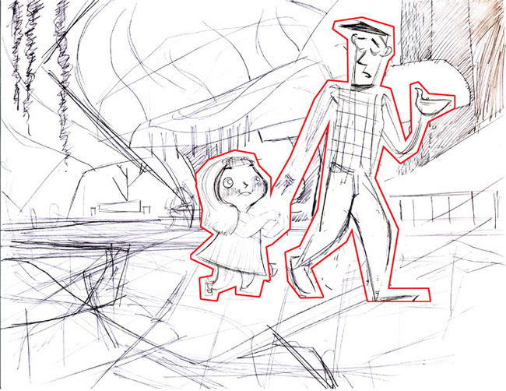
Fig.2

SHAPE BLOCKING
STEP 4: Leading the Eye
I decided to show this stage early on, to visualize a key theory in painting. Composition is everything!
The block shapes, represented by the dark areas, are used as guides to visually direct a viewer through a given image. The goal of an artist is to inspire a viewer with enough visual interest to explore the entire span of your created work. Sometimes this is done in very abstract ways, but it is done. Whether it be physical or psychological, the viewer should be led through your image. Anything a viewer takes away after that, is subjective appreciation.
(see fig. 3)
In this image, as illustrated by the arrows superimposed onto it, you see the path I want the viewer to travel when admiring my work.
(see fig. 4)
For arguments sake, I do not claim that this is the only way to approach an image. However, it is a good idea to start conditioning yourself to understand that thinking through a picture (especially in the beginning) will be more effective than just jumping right in. A good plan will go a long way when creating artwork.This theory should not be limited to drawing. You should also utilize it when dealing with color, in both hue, value and rendering (the act of marrying all these elements together).
Be spontaneous here, as in your thumbnails. Allow yourself some further chances at freedom when establishing your blocking rules. Simply concern yourself with what and how you want the viewer to experience your work.

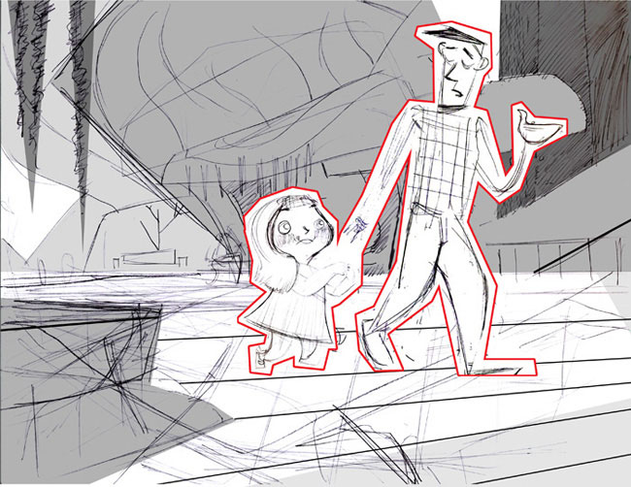
Fig.3

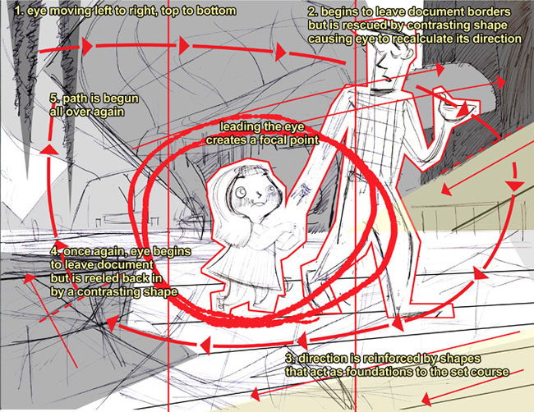
Fig.4

FINAL LINE
STEP 5: Clean Line Drawing
For the purposes of this walk through, I needed to make a clean version of my finalized rough layout. (see fig. 5) This clean line will be used later in this process to incorporate some traditional elements into my digital painting (more on that later). When creating a painting, this clean line step is not always necessary. However, it does serve as good drawing practice... so don't be afraid of it!
Open your drawing in Photoshop (see fig. 5a) duplicate your line drawing layer, and set this duplicated layer to Multiply (see fig. 5b) By doing this you make anything in your drawing that's white (see through or invisible) this allows you to use your black line as a guide when painting. And if you prepared a clean line drawing which is made up of continuous connected edges (see fig. 6) (edges that create closed shapes in your drawing) you can use your magic wand tool to select these shapes. This gives you the ability to isolate shapes within your drawing as you render. And in addition, since this multiplied layer exists as only one layer, you don't have to worry about too large a file size ( a problem that occurs if you save a channel for each shape you like to work with)
As in real paint, having the ability to work with individually selected shapes is similar to masking out an area of your painting with something like frisket (a material that allows you to isolate a specific area of a painting)
Do not abuse this technique of isolating shapes. It will cause you painting to seem disconnected. The shapes run the risk of having different rendering qualities, or color that does not relate to adjoining shapes, etc. Use this technique only when necessary, for areas that may require special attention. Remember, even though we're working digitally, we don't want that fact to be easily recognizable.

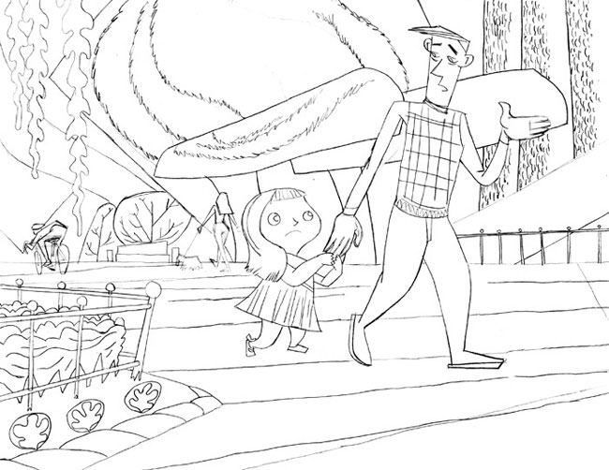
Fig.5

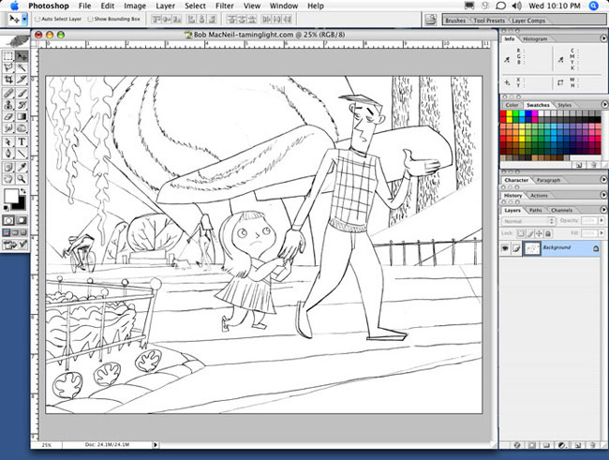
Fig.5a
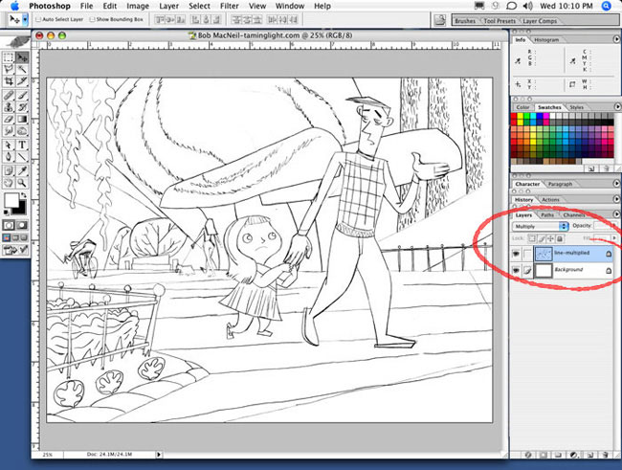
Fig.5b

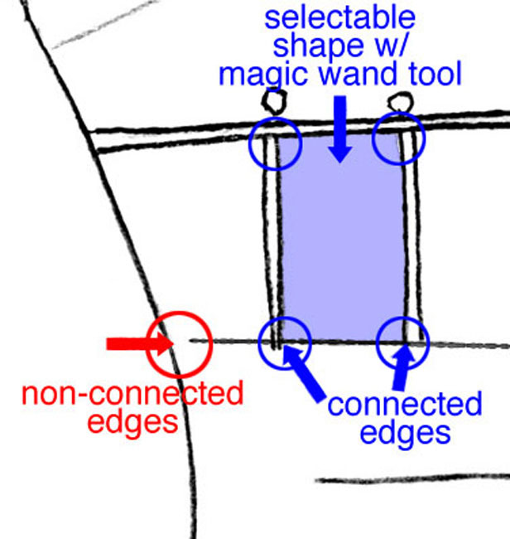
Fig.6

PAINTING
The act of painting or laying down brushstrokes
1. When laying down general brushstrokes, do your best to not be neat. Work with a brush that has its opacity setting set less than 100%. By working this way at the start of a painting, (when you're goal is to be as loose as possible) you will create a noticeable overlap of color that gives you variations in paint density (OVERLAP-when a brush stroke passes over a previously recorded brushstroke on your image, this area has essentially been hit with an additive amount of paint that would turn an 50% wash of paint to a 100% wash of paint) (see tech. 1) This overlap will give you a nice representation of true paint effects. In the final rendering, these mistakes you make early on push the illusion that you painted this with real paint. The key is to not lose these overlaps or mistakes. Don't use the tricks that come with Photoshop, try to paint with a minimal amount of layers, and try to use a small amount of brushes, both styles and sizes. Don't use the lasso or path tools to make a perfectly selected area, allow the brush edge to define a shape. The unsteadiness of your hand and a given texture of a brush will give you the feel that you're working on a real textured surface. YOUR BIGGEST ENEMY IN DIGITAL WORK IS PERFECTION. It's easy to noodle a painting when you can zoom to 1/32 of an inch with resolution clarity, or when you have an unlimited amount of brush tips to work with. In reality, paint brushes are expensive, so you typically do not need every one that's in stock at your local art store, so treat Photoshop like reality and keep a limit on the amount of brushes you use. It will help keep a fresh feel to your work and eliminate any potential headaches caused by the overwhelming amount of resources Photoshop offers.

2. When you make the physical brushstroke, try your best to paint in a direction that the shape your painting dictates.
In the red example (see tech. 2) this shape was colored in as if it were a child's coloring book. I did my best to try and stay in the lines and create a nice clean edged shape. By doing this, I had to use brushstrokes that lacked reason, because my only intention in this example was to fill the shape with color. This lack of reasoning may cause a bothersome feeling about your image which if carried through an entire painting can cause a viewer to feel an uncomfortable disturbance they can't put their finger on. A viewer will feel like there's something artificial or incorrect in your image (as evidenced by the messy shapes created by the darker red areas). This negativity then can potentially emphasize or reinforce any other negative feelings a viewer may have, but may not actually be aware of and cause your image to be unexplainably disliked.
I suggest approaching your physical brushstroke as I did in the blue example (see tech. 2) Notice the stroke follows the flow of the shape it's defining. This flow will give off the impression that there is a nice fluidity to your paint application. It will cause the viewer to feel comfortable with what they are viewing. Your paint application will appear as if there were an intention to your whole approach, and it may even cause additional positive reactions for a viewers experience. As in real paint, this technique can be equated to the "paint through an object" theory. If you have ever had any experience with traditional paint (see what I mean) you will more than likely have heard this expression at one time or another. Paint through literally means that. Paint through a shape, do not concern yourself with maintaining edges. (see tech. 3) (this should only concern you when you reach the final stages of detailing) It will also emphasize the theory of leading the eye as explained in the blocking stage. Paint direction can cause a viewer to look where you want them to.

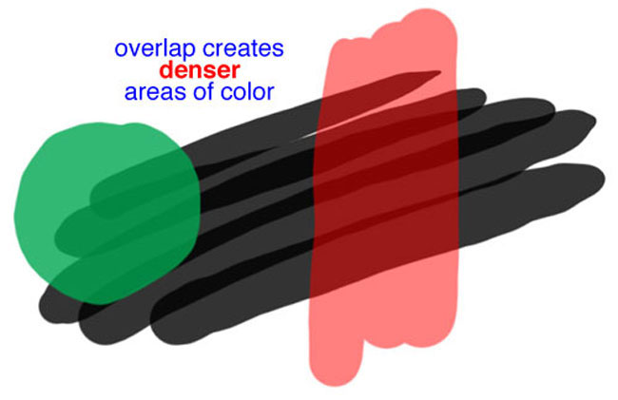
Tech1

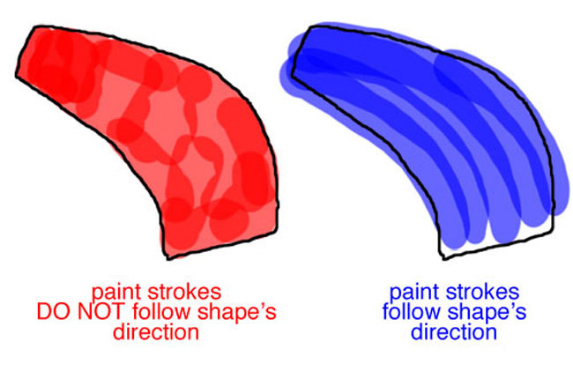
Tech 2

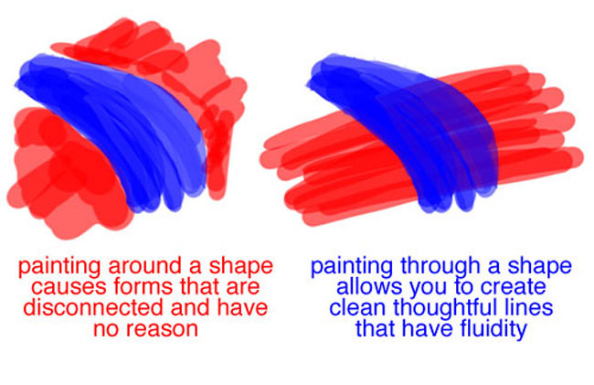
Tech3

PAINT BLOCK-IN
STEP 6: Applying Color and Texture
Different, yet the same as shape blocking. This step brings life to your drawing. In shape blocking, you learned how to lead the eye by establishing a shape path it could follow through the drawing. In paint blocking, you do the same, but you take a somewhat different approach, in that you now use color to lead the eye. In this step, you will also learn how to work from big to small, back to front, dark to light. And hopefully, you learn why these approaches are important.
First off, for arguments sake... Let's say the canvas or document you have to start with is white. Nothing interesting or visually stimulating, just plain old default blah. As a painter, you want to cover that document with color as quickly as you can. Color adds interest, direction, mood and painting with white would probably not show up in printing. Keep this stage loose and just concern yourself with eliminating the raw page.
In paint, you do not want to rely on lines to define your edge. In reality there aren't outlines on things. Shapes are clarified, visually, by edge contrasts, so having a good clean edge on an object and a color or shape behind it that pronounces that edge is how you define forms that a viewer sees within a painting. In any given painting, the farther most objects should be painted first. This level of paint could simply be called the (background color level) (see fig. 7). The next step after painting the farthest objects (or background level) in your scene, is to paint the next level (or foreground color level) (see fig. 8) above the background level you've already established. You can actually have as many levels as you need, but I suggest keeping it simple to eliminate any unnecessary confusion. I limit myself (as often as I can) to a background, middle ground, and foreground level. Is this tutorial, for simplification reasons, I did not use a middle ground. Nonetheless, no matter how many levels you need, simply keep them separated by layers(A function of digital media that has a huge advantage over traditional painting) By doing this you will not have to worry about an accidental overlap of previously applied paint which would compromise an established shape edge. Characters are put onto their own layer to allow the opportunity for any specialized rendering they may need. (see fig. 9) This way, I could also add any extra detail a character needs to make its presence even more effective in an image. As is with shape blocking, color should be handled similarly. Certain colors will lead a viewer to feeling one way or another about a painting. There are tons of resources available that explain this philosophy (so I will not get into that here) but my approach to this is to use color where I feel it works. I logically think about what would work in a given situation, i.e. light source, time of day, mood I want to portray, place, etc. and I block in loose color. This step has similarities to shape blocking when you start using color to attract the viewer. By combining this method with a good sense of shape blocking, you create an additive sense of clarity and solidity to your painting that will help it appear "right" to a viewer. In an image that's predominantly green a red element will stand out. Red in this example is used to attract or lead a viewer. So when applying color keep in mind the "leading eye philosophy", as exampled by the blocking in stage.
A general guideline to work with is:
• Keep your workspace clean and easy to understand. It's very easy to go wild with the amount of layers you use, so a good rule to adhere to, is KEEP IT SIMPLE.
• Viewers are attracted to lighter colors when surrounded by a darker color field.
• Complements on the color wheel (the colors directly across from one another) make good contrast, and in rendering add value (the shadows on a shape) to a color.
• Darker colors recede, when lighter colors amplify

There are plenty of theories out there to explain and support this stage. For instance, I suggest you search "color wheel theory" for some extra curricular work.
Keep in mind what I've told you so far (in previous lessons) and in a short time, even without any attempts at detailing, you will find a certain clarity develop in your work. (see fig. 10) Stay loose, keep in mind a light source, time of day, and mood you want to project and allow this process to be easy and somewhat fun. You may even uncover a direction for your paint block-in originally not envisioned by being loose. I completed this stage in about an hour. It took that long because I had to really think about what I was doing to properly write this tutorial.

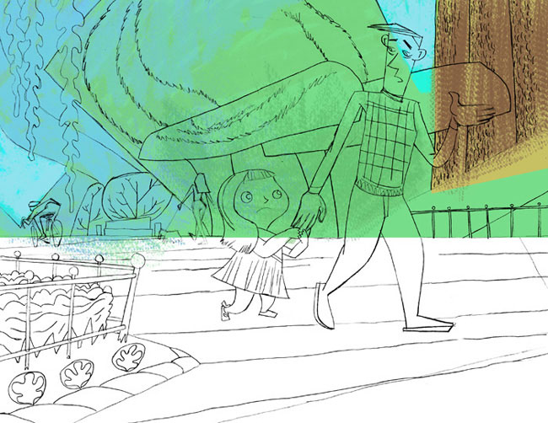
Fig.7
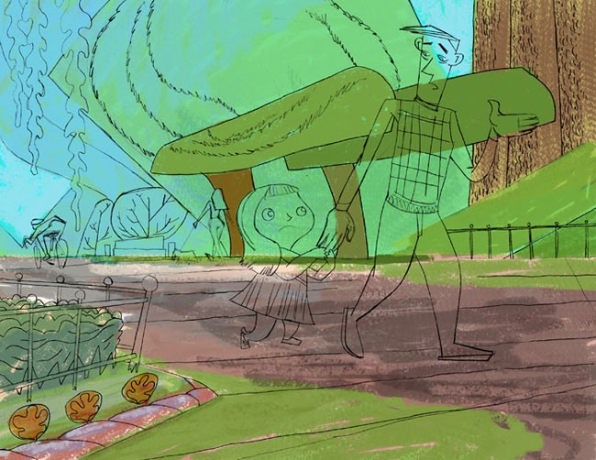
Fig.8

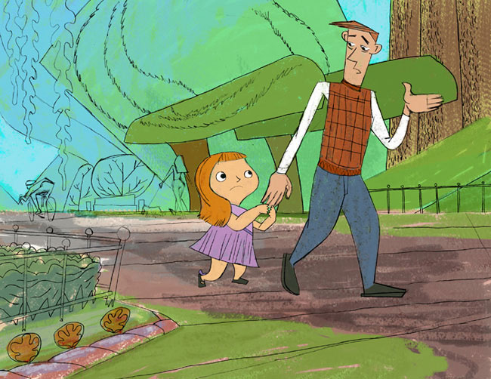
Fig.9

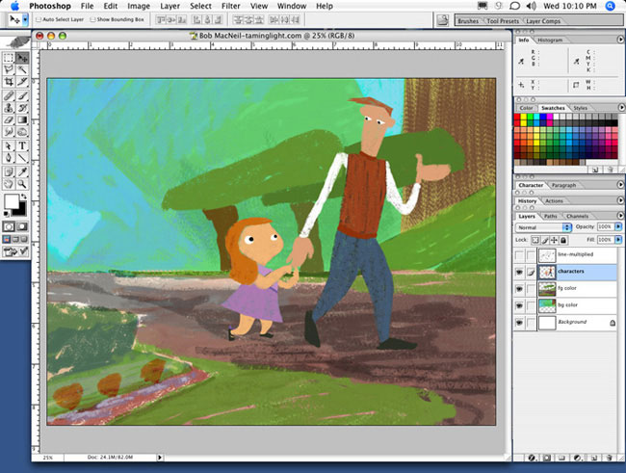
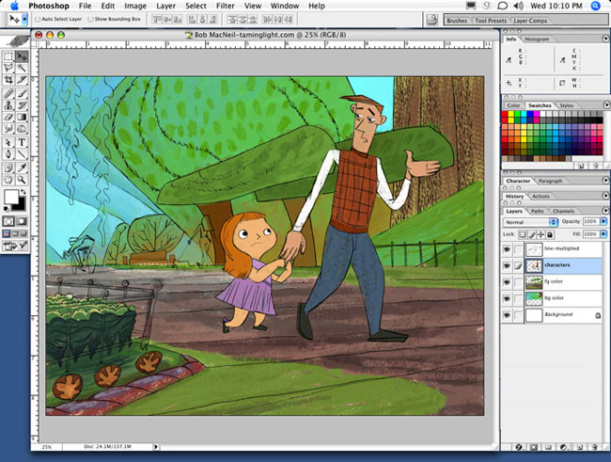
Fig.10

DETAILING

STEP 7: Refining and Clarifying
This is the stage that most people consume themselves with. When in truth, this stage doesn't have to be as labor intensive as some may think. Sure it can be, depending on the proposed forum your art is intended for, but typically it doesn't have to be. If you logically approached your art in the previous stages and completed them with some bit of intelligent thinking, you may already almost have a finished painting. Details are, and should only really be the final touches to an already understandable piece of artwork. They are, to sound lame, the icing on the cake. They aren't the layers of dough that make up the brunt of the cake, but they are the sweet indulgence we all fall victim to. This is why, most amateurs dwell way too long on this stage. One thing to realize is, all the detailing in the world will not rescue a painting with bad foundations. With that said, details can also be added to an image with their own layers. (background detail = bgdetail, foreground detail = fgdetail and character detail layers) (see figs. 11, 12 and 13) By doing it this way and not painting directly on your blocked in color layers, you can try to maintain the spontaneity you have already established. A layer allows you infinite levels of refinement, the only thing that obstructs that fact is practicality and if your a professional... budget. Aside from that you could experiment all day, however, I don't recommend doing this. I suggest you handle your digital document as if it were a traditional canvas or illustration board, commit yourself to not falling into the bell and whistle trappings of digital creation.
For a final stage, I like to add a color adjustment layer to marry the whole layout together. This is not a necessary step, if you consider your paint choices at this stage should be pretty consistent, but it is there if needed. In this example I needed it, so there it is. (see fig. 14)
With that in mind, this point brings us to yet another theory. It's one that focuses on digital painting.
Treat digital paint like it's real paint. In real paint, changes or manipulations are difficult to facilitate. In digital, they're not. This means you have to be very cognitive of following rules and guidelines. The best way to do just that is simply treat digital as if it were traditional. For example, when painting use a texture brush (why not, they're readily available in Photoshop) however, apply a brushstroke and stick with it. Apply the brushstroke as if you were holding a paintbrush, even though you're using a mouse or tablet. Commit yourself to the illusion that your monitor is a canvas. If you make a mistake on a canvas you paint over it to correct it, you don't have an erase tool in real world conditions. Use a limited amount of paintbrushes. Stay away from filters, etc, etc, etc. Now, you may ask yourself, "Why should I paint digitally then?" And my answer is, digital allows you to experiment with ideas or outlets you may never have considered. It's relatively fast, and you have little (if any) cleanup. Do not eliminate what digital offers, that's not what I mean. However, do not abuse it either. It's a tool, and should be used for its advantages, but do not let the tool dictate your actions. By working with this mindset, you will find that your work (even though created digitally) will still evoke a traditional feel. Of course you will not have a tangible object, such as a painted canvas, as you would if you worked traditionally. Yet, your work will not look artificial and overworked (as it easily could when working digitally) Strive to keep the two, traditional and digital, indistinguishable. If you do this, you avenues for work will not be limited.

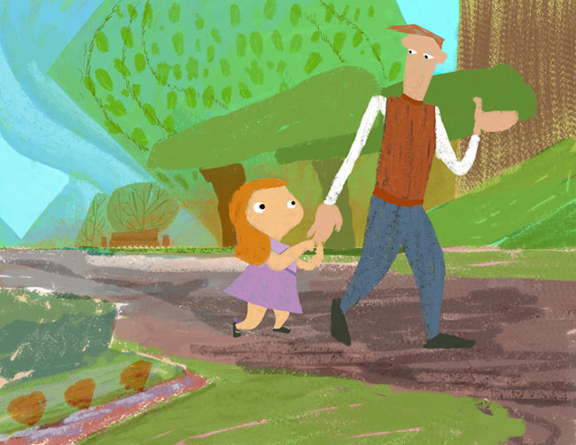
Fig.11
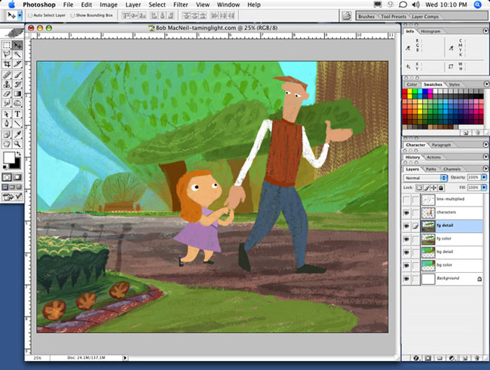
Fig.12
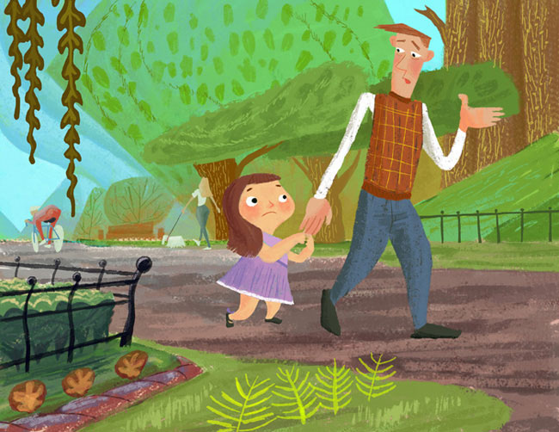
Fig.13
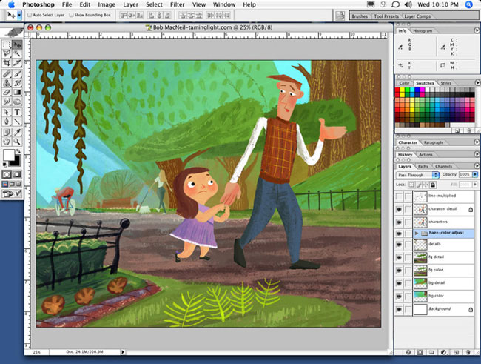
Fig.14

LINE GRABBING
STEP 8: Using the quality of the Final Clean Line drawing, in a channel selection, to tighten and clarify paint details and edges.
Below I attached a step by step image sequence to visually explain this process. I will also explain it here for those interested.
Step 1: Add a new channel to your painting document.

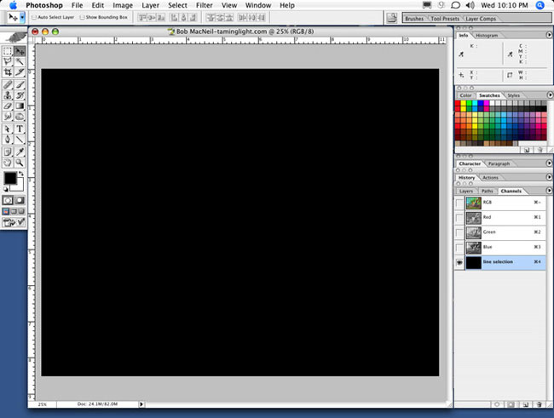

Step 2: With the newly added channel selected, access the pulldown menu from the "image" section at top of interface, and select the option "apply image".

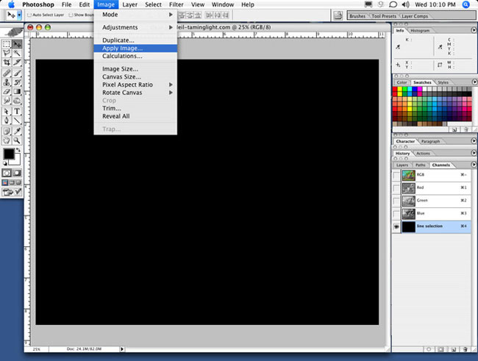

Step 3: A second window appears, titled "apply image". Select the layer pulldown option (now select the layer you designated for your final line drawing, in this example I titled it "line-multiplied”)

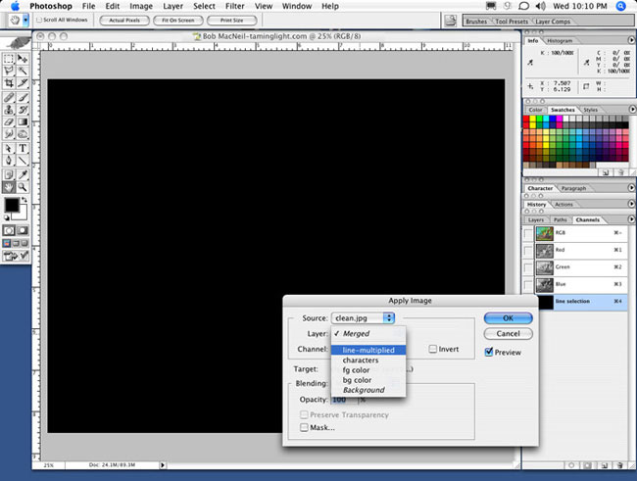

Step 4: Select the blending pulldown option (which by default is set to multiply) and change it to "normal".

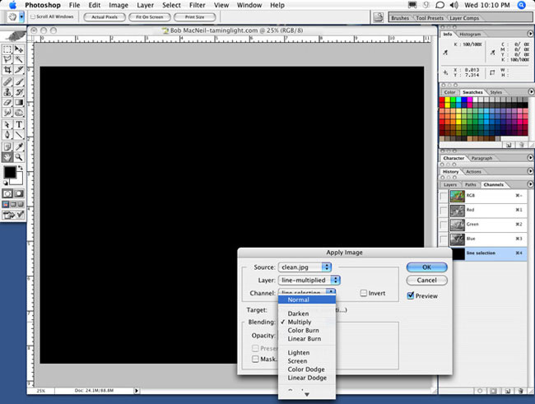

Step 5: Select the channel pulldown option (which by default is currently set to the channel your working with, in this example it's titled line selection) and change it to "RGB".
(note: at this stage (if you have followed the steps correctly) your final line drawing should appear as it does in the example).

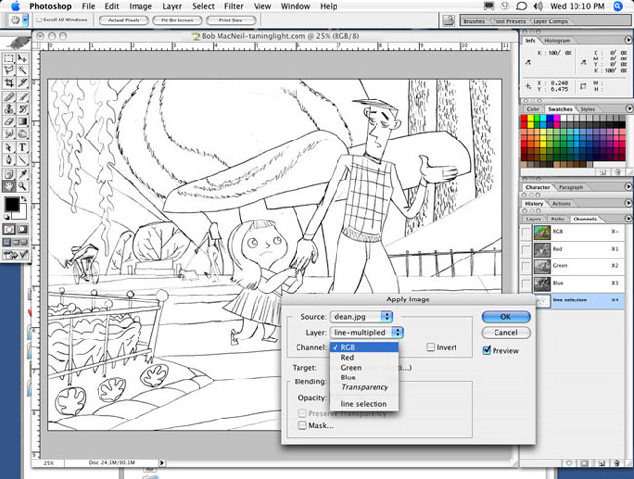

Step 6: Select "invert" to change your final line drawing to appear in negative.

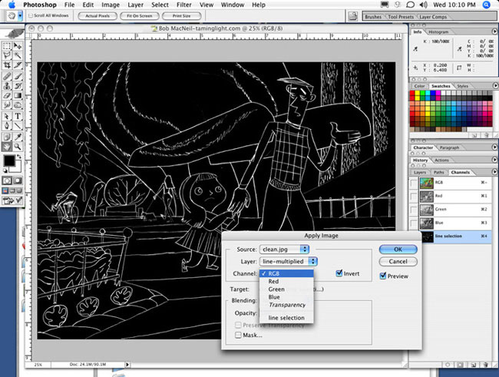

Step 7: Access the pulldown menu from the "select" section at top of interface, and select the option "load selection".

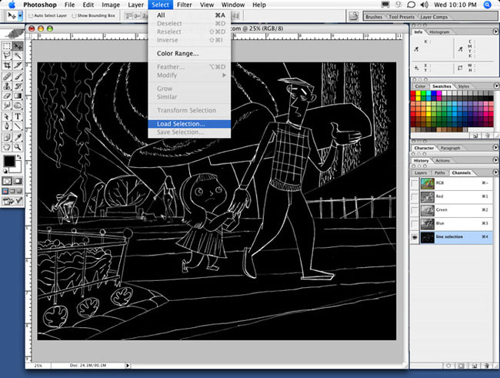

Step 8: A second window appears, titled "load selection". Select the channel you just created from the channel pulldown. In this example I titled it " line selection", and click ok.

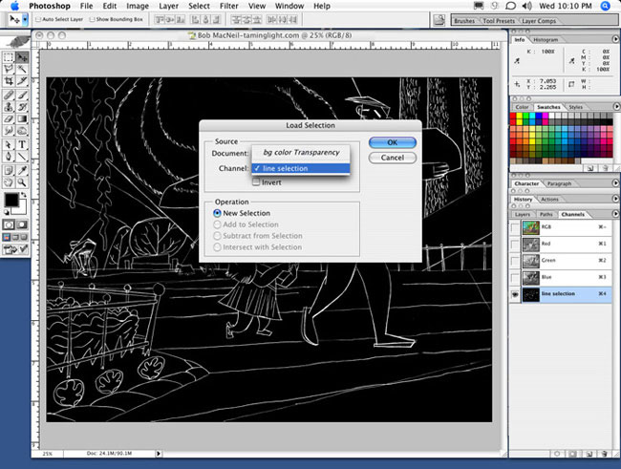

Step 9: If you have followed these steps correctly, you should have a loaded selection that is generated from your final clean line drawing. In a channel mask, white represents the areas that are selectable and black represents the areas of the channel that aren't. If you have a channel with grays in it, those areas are selectable based on the percentage of white they contain. (i.e. 50% gray will allow you to paint through that area of selection with a 50% amount of opacity strength).

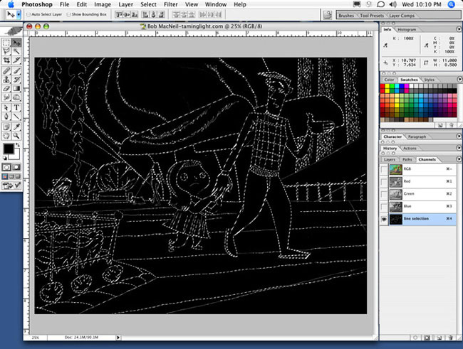

By doing this you have made a channel that allows you to use your final line art as a mask when drawing or applying paint. So now your line drawing can be used to input clean and decisive lines into your drawing that provides your detailing stage with an extra amount of confidence.

FINAL ART

